*Experiment-15*

CREATE TABLE Doctors (

doctor_id NUMBER PRIMARY KEY,

doctor_name VARCHAR2(100),

patient_id NUMBER,

discharged VARCHAR(3)

);

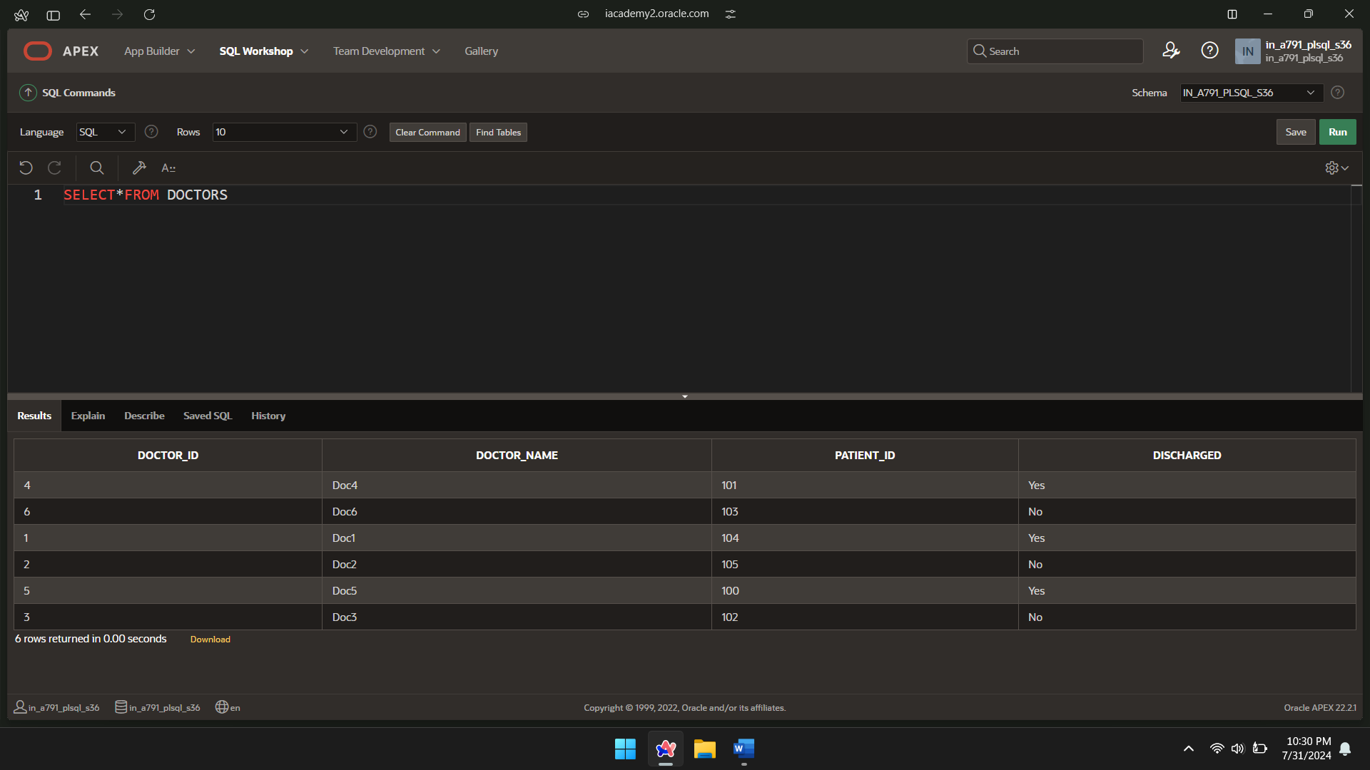

CREATE TABLE hospital (

patient_id NUMBER PRIMARY KEY,

patient_name VARCHAR2(100),

status VARCHAR2(20)

);

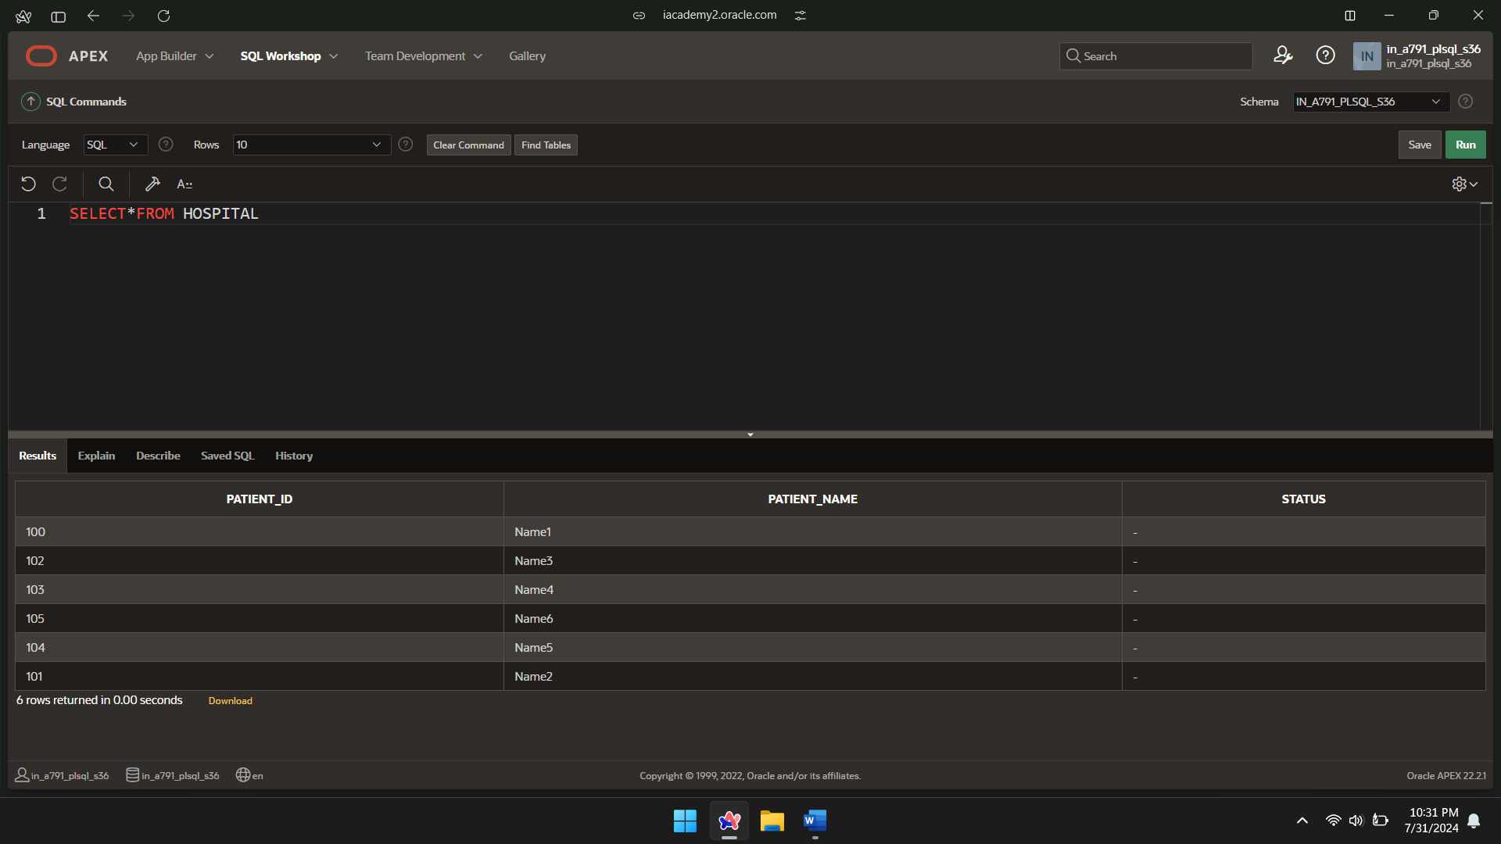

DECLARE

CURSOR s1 IS

SELECT patient_id, discharged

FROM Doctors;

v_patient_id hospital.patient_id%TYPE;

v_discharged Doctors.discharged%TYPE;

BEGIN

OPEN s1;

LOOP

FETCH s1 INTO v_patient_id, v_discharged;

EXIT WHEN s1%NOTFOUND;

IF v_discharged = 'Yes' THEN

UPDATE hospital

SET status = 'Discharged'

WHERE patient_id = v_patient_id;

ELSE

UPDATE hospital

SET status = 'Admitted'

WHERE patient_id = v_patient_id;

END IF;

END LOOP;

CLOSE s1;

END;

/

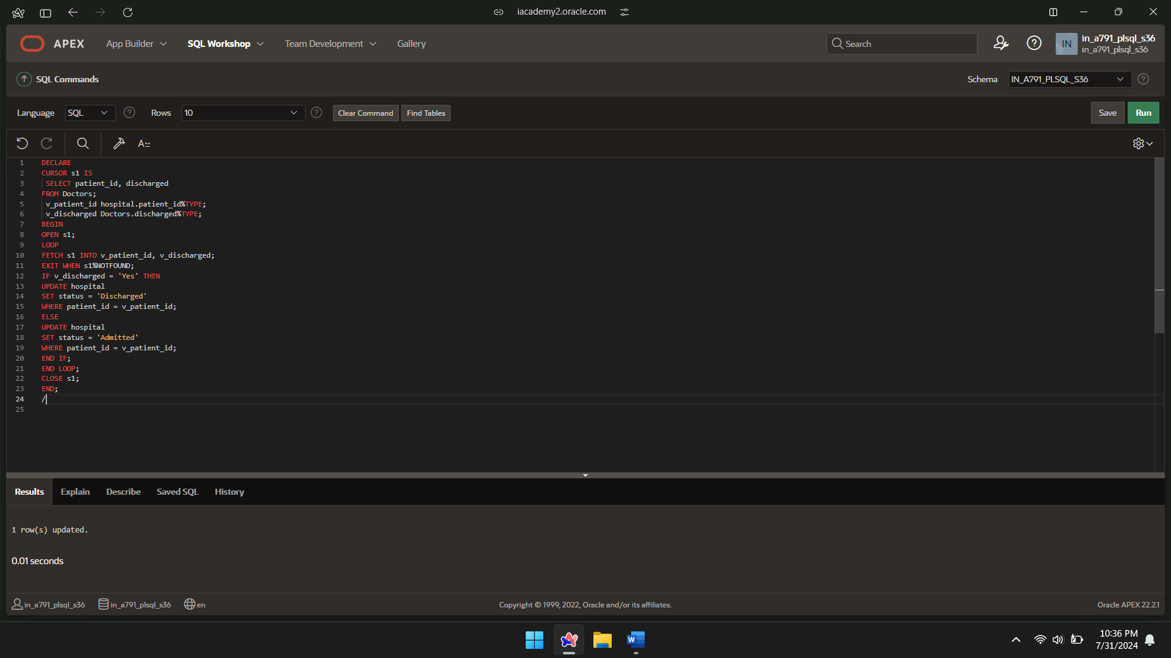

SELECT*FROM HOSPITAL;

